

NOVAC TECHNOLOGY SOLUTIONS

User Manual

Document Version No.: 1.00

Revision History
Version No | Reason For Changes | Author | Approver
0.01 | Draft
1.00 | Reviewed & Approved the User Manual

Table of Contents
1. Introduction 4
2. Master CTPL Proposal & Policy Generation 4

Introduction

The document is prepared to understand and build an application for Fleet master CTPL Insurance to the insured.

Fleet Master Proposal & Policy Generation

Path: Engineering -> Master Policy Dashboard
Screen Code: S0520

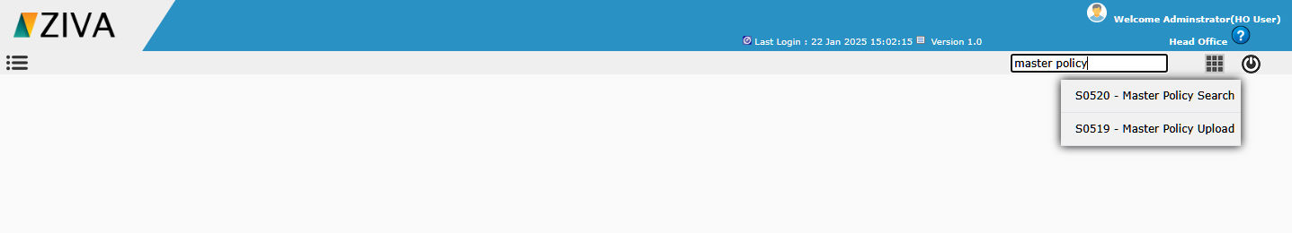

After selecting the sub Line and policy type details, on clicking Go button, remaining fields to capture the proposal details will be displayed.

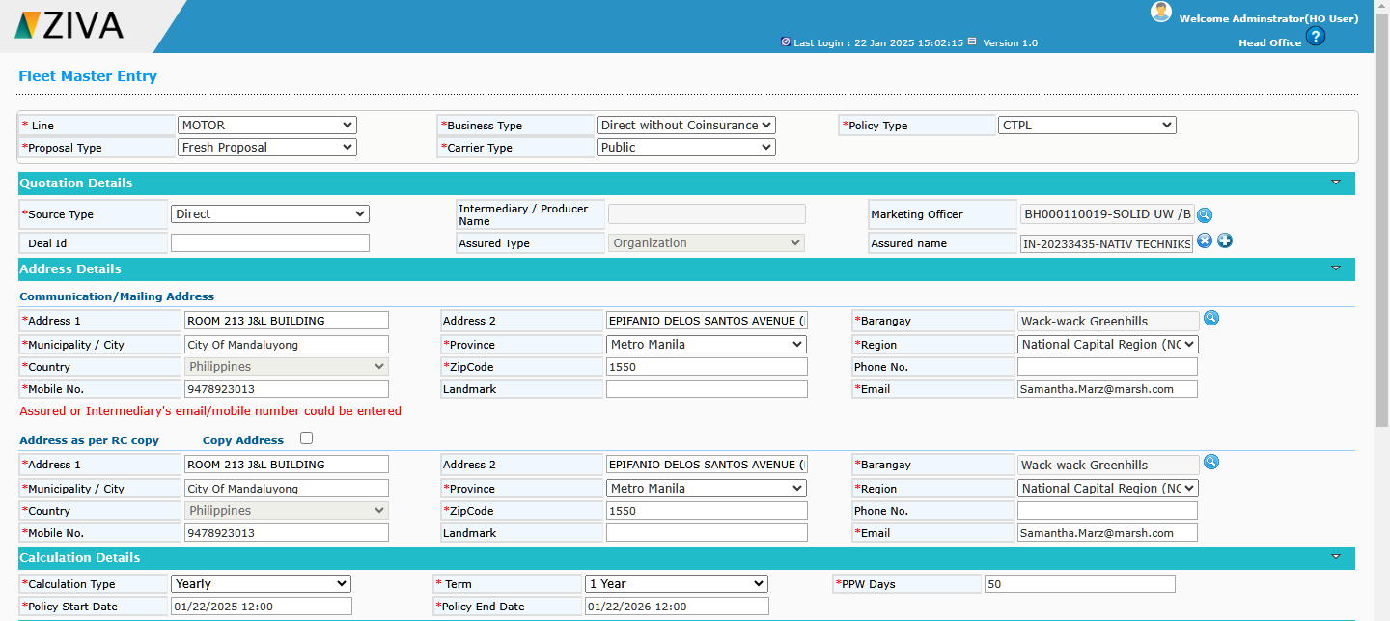

In Coverage details, click on Add new policy icon, user can able to create a new Master policy.
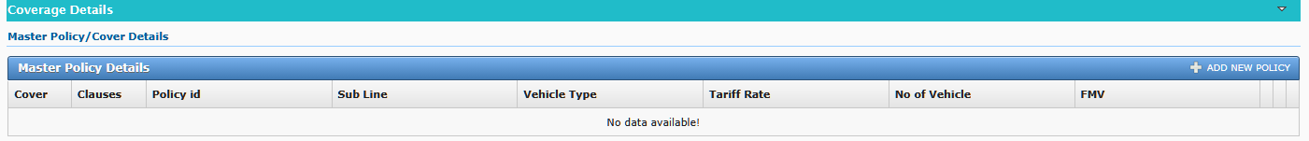
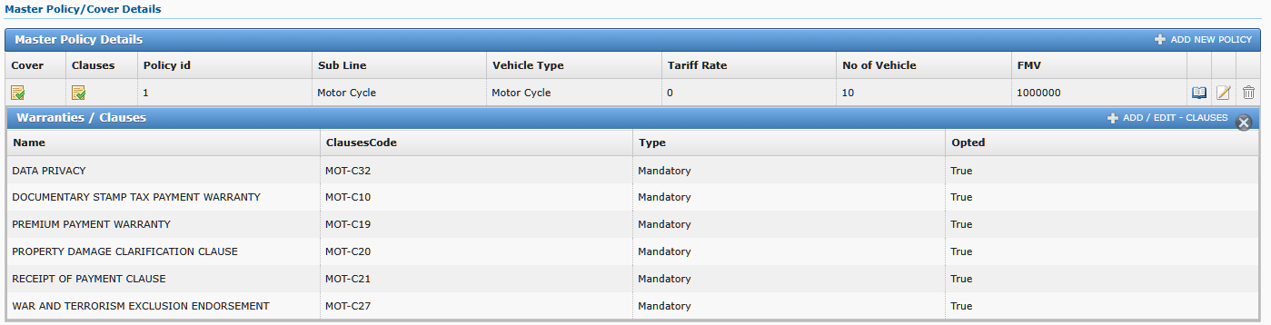

On clicking Save button, system add the Cover details.

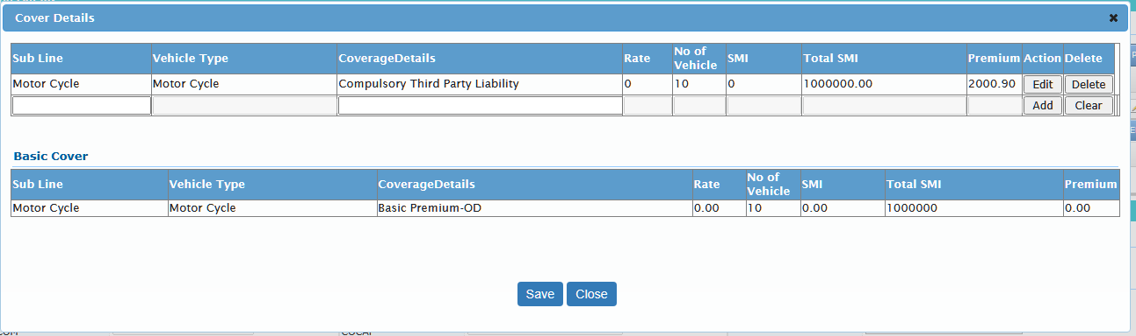

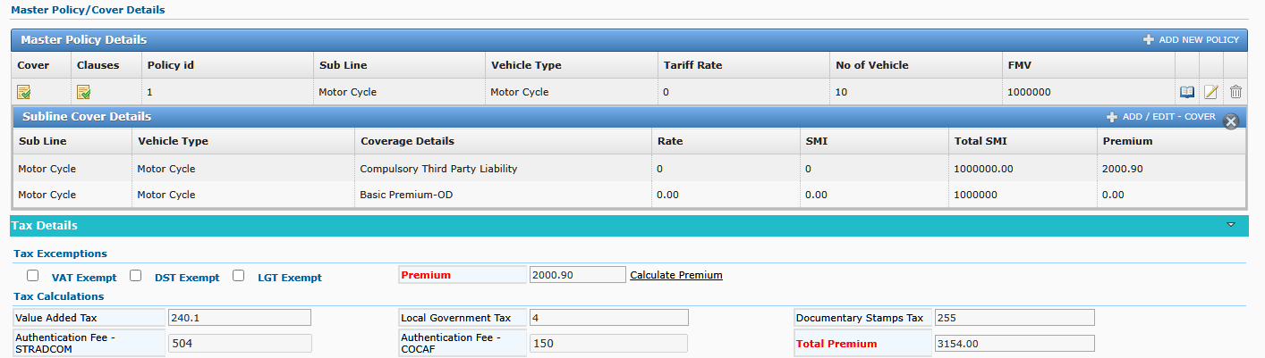

After entering all the details and click on calculate premium user can generate a Quote and then covert a proposal and generate a Master CTPL policy.

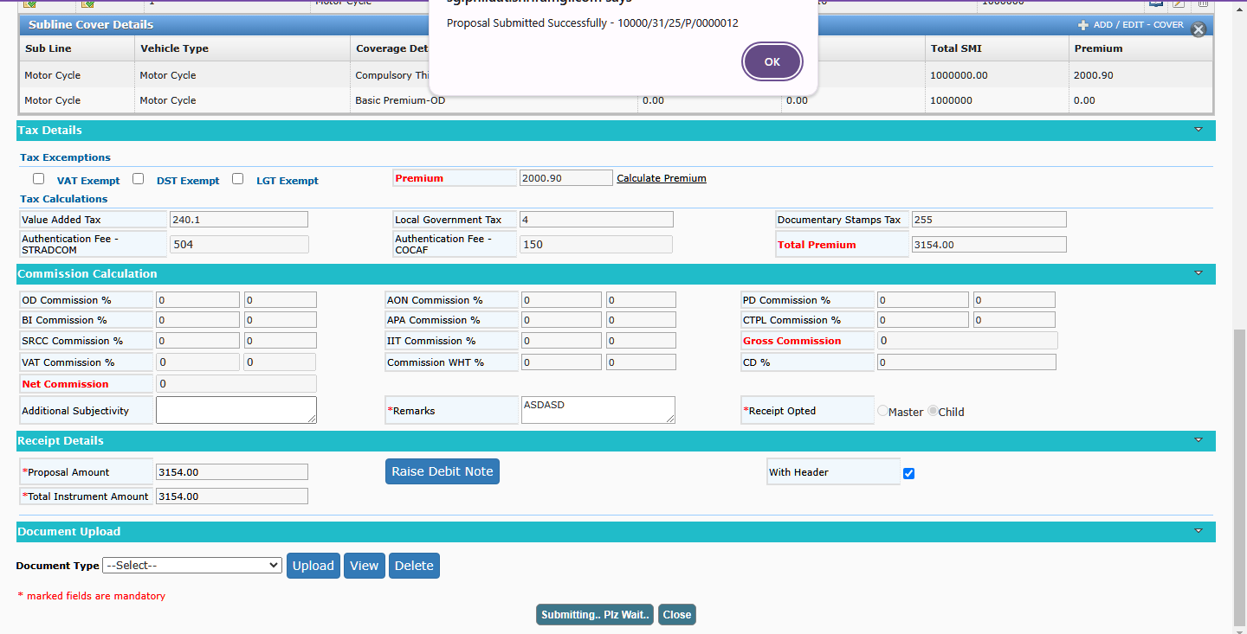

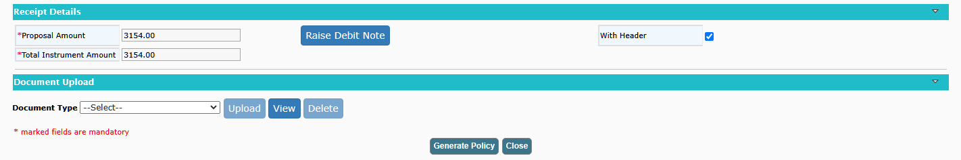

After Master Policy generation, go to CTPL Bulk upload screen.

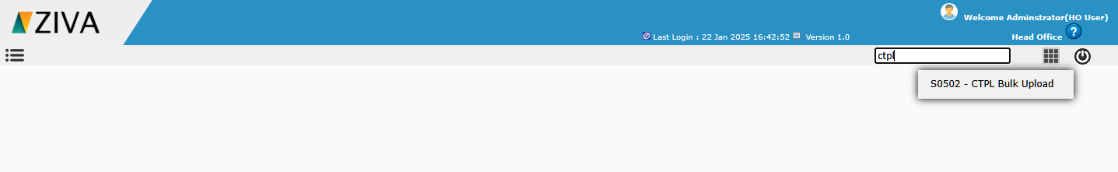

Choose the request type as Proposal generation and upload the CTPL Bulk upload Excel, and click upload button.

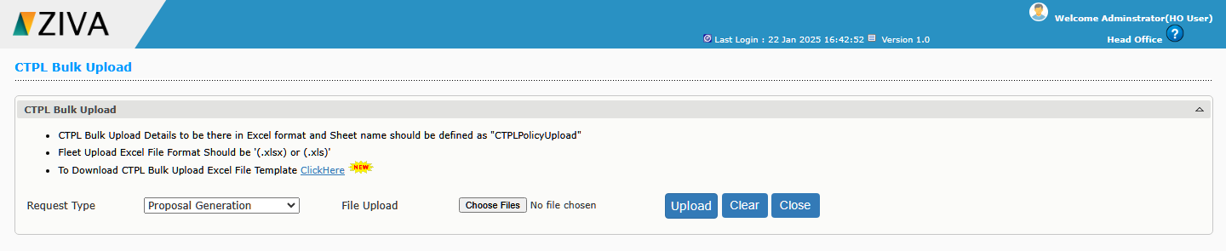

Choose the request type as Policy generation and select the Batch no, and click the generate Button.

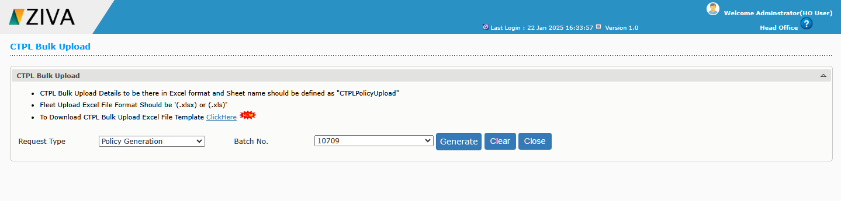
Click view button to download the policy.

